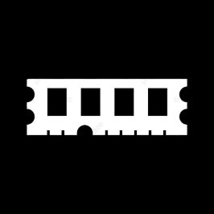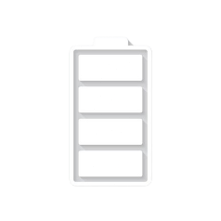

Redmi Note 11

* Processor: Qualcomm SM6225 Snapdragon 680 4G (6 nm)
* Front Camera: 11 MP
* Rear Camera: 50 MP
* Display:6.43 “
* NFC: Yes
* Colors: Graphite Gray, Twilight Blue, Star Blue Operating System:
* Android 13
* Charging Type: USB Type-C
* SIM: Nano-SIM
* Fingerprint: Yes
* Release Date2022, January 26

Price: $208

RAM

6

GB

ROM

128

GB

BATTERY

5000

mAh



+001-28272300-2466-2469



webmaster@cellinfo.com



A-65, ACME Co. ,

Street No. 12,

New York

Ask Me Ltd.